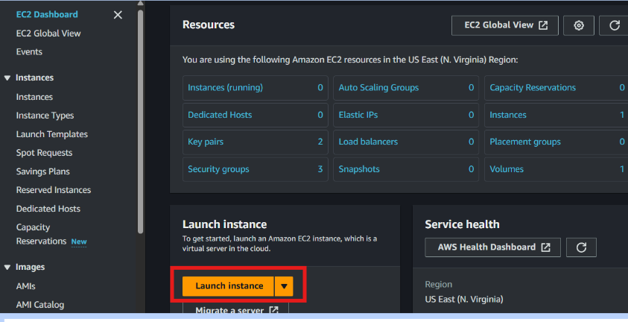

1.In the AWS Management Console, search for "EC2" and select it from the services menu.

2.Click on Launch Instance.

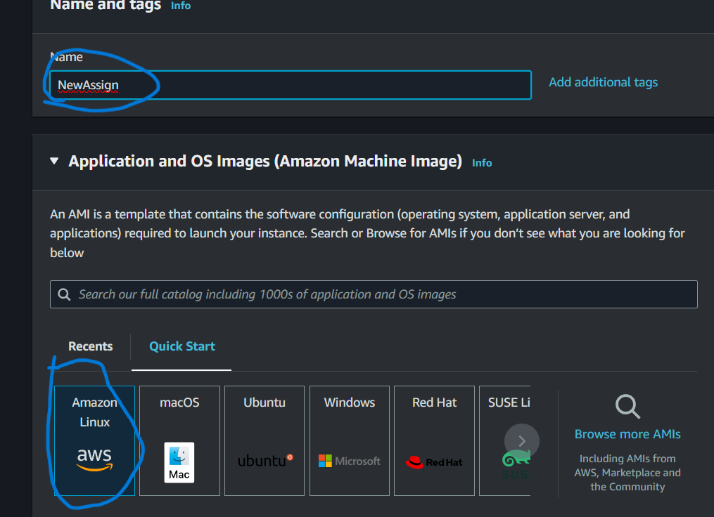

3.Then name your Instance

4. Choose an Amazon Machine Image (AMI)

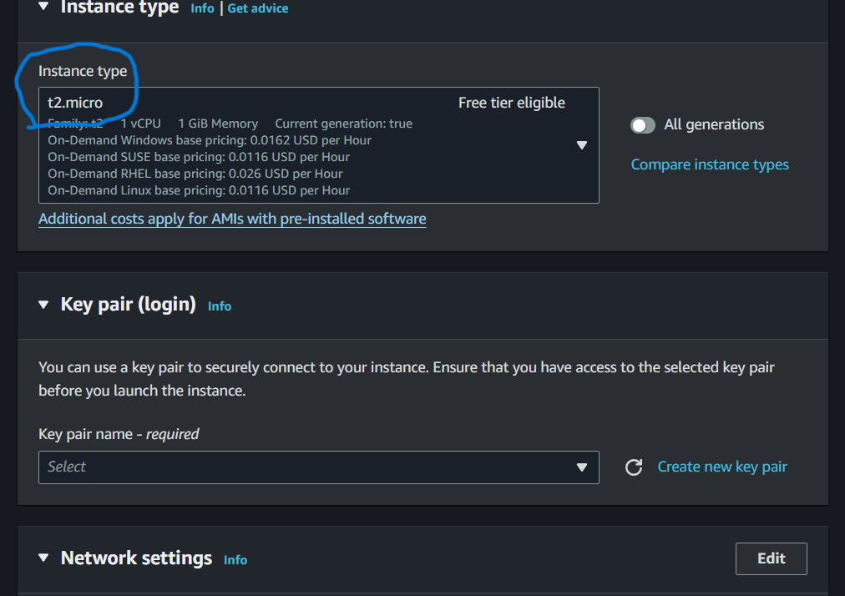

5.Select an instance type (t2.micro)

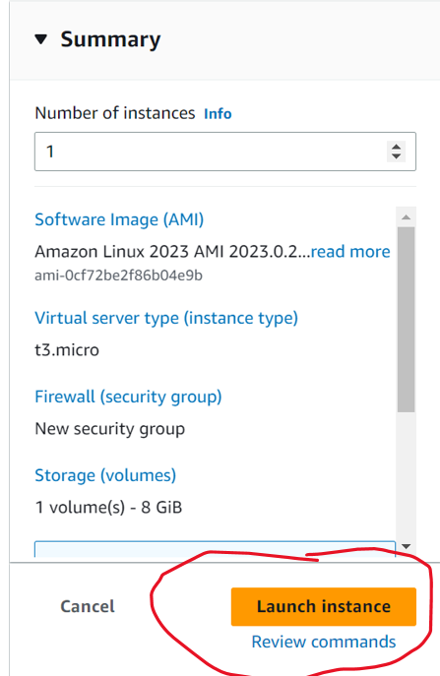

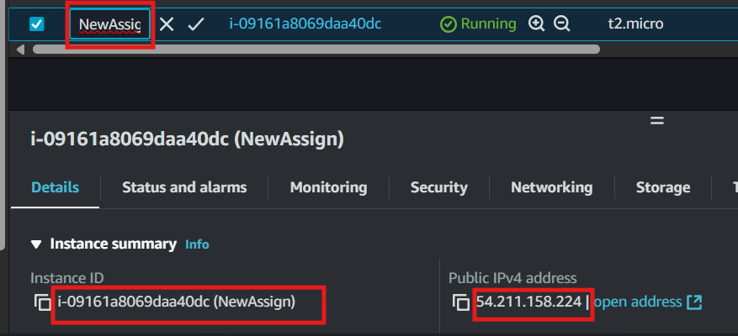

—-----------------------------------------------------------------------------------------------------------------------------------------------------------------------------------------------------------------------------------------------------------

Q2.

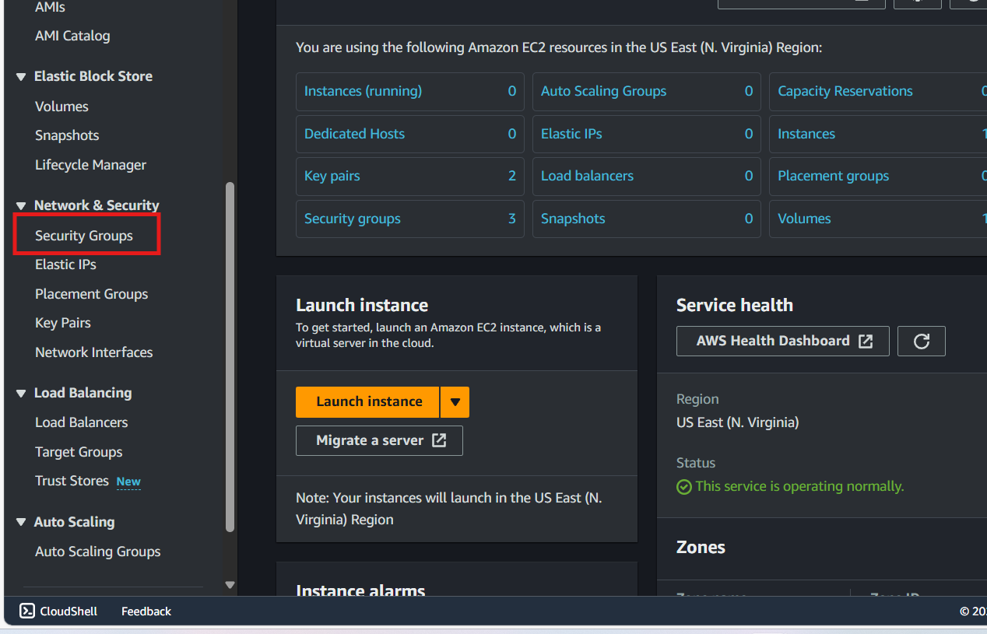

1 .Go to the AWS Management Console and select **EC2**.

2 .In the left-hand menu, click on **Security Groups** under the **Network & Security** section.



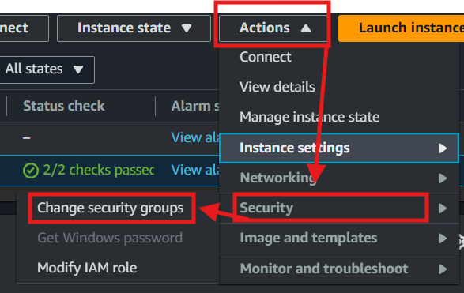

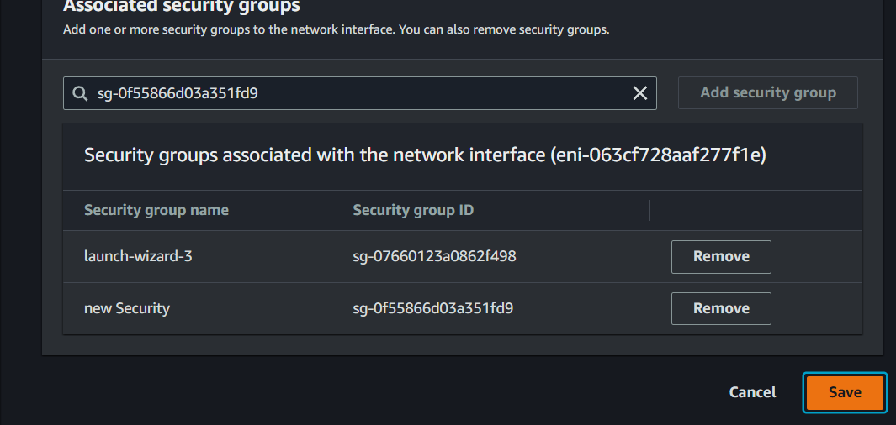



New security added to the my e 2 instance

—-----------------------------------------------------------------------------------------------------------------------------------------------------------------------------------------------------------------------------------------------------------3 **Install and Configure a Web Server**:

* + Connect to your EC2 instance via SSH and install Apache or Nginx.
  + Verify that the web server is running by accessing the public IP address.

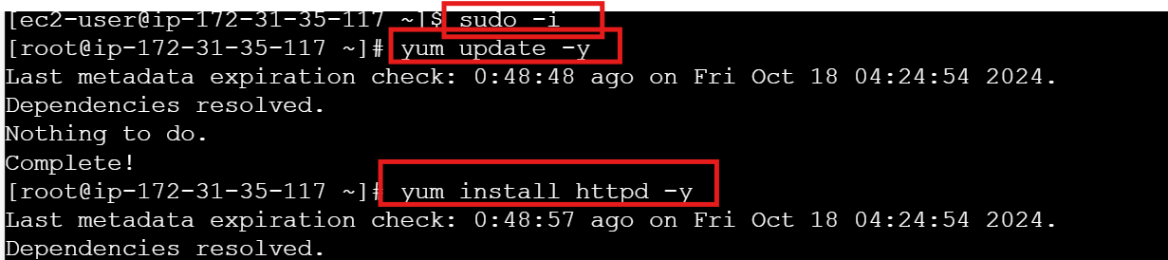



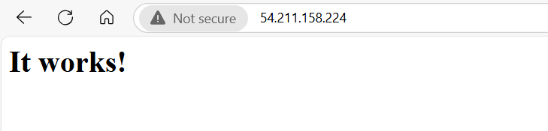

—-----------------------------------------------------------------------------------------------------------------------------------------------------------------------------------------------------------------------------------------------------------

4 **Create a Bash Script**:

* + Write a script to automate the installation of the web server.
  + Document your script and its functionality.

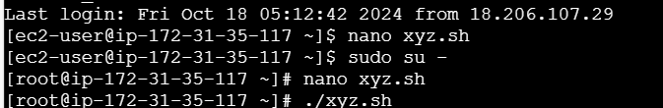

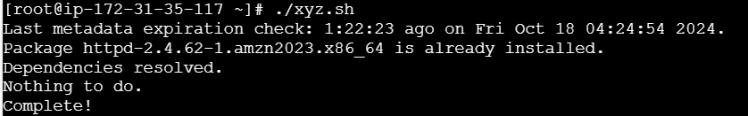

**-5.Task**:

* + Submit a report with screenshots of the EC2 instance and the web server running.